RESUME

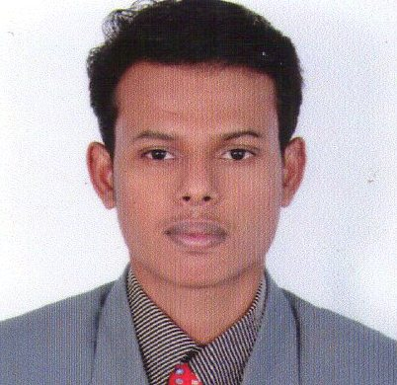

SUBRAMANIA PILLAI.P No-113, Bajanamada Street,

 +91-9789599710 Marungoor,

E-mail : subashmaestro@gmail.com Kanya Kumari dist,
Pin code-629402

CAREER OBJECTIVE:
To acquire a position in company that challenges my knowledge there by being resourceful, creative and innovative.

HIGHLIGHTS:
- Belief in team work, Initiative, Hard work, Sincerity and the will to carry out the assignment in the specified time limit.
- Mettle to prove efficiency in niche of employment.

ACADEMIC DETAILS:

2008-2012 B.E degree From CAPE Institute of Technology, Levengipuram,

Affiliated to Anna University and secured an aggregate of
76 % (Up-to 6th SEM).
2007-2008 XII from S.M.S.M Higher Secondary School at Suchindrum, (State Board) and secured an aggregate of 91%.
2005-2006 X from Govt. High School at Eraviputhoor,
(State Board) and secured an Aggregate of 82.3%.

mINI PROJECT:
TITLE: Solar Desalination Of Sea Water

DESCRIPTION: This project is aimed at developing idea about reducing the scarcity of pure water. In this project we are make an idea about how to convert sea water into pure water, this project becomes very cheap because of there is no use of external electric supply with use of solar power.

MAIN PROJECT:
TITLE: Graphite Glass Reinforced Plastics

DESCRIPTION: This project is aimed at developing idea about making of new material with high strength. It has high strength, relatively lower cost, high stiffness. So we are choosing composite material. Now a days current research are going in this field.

SOFTWARE SKILLS:

Languages Known : C, C++.
Operating System : Windows XP, Windows 7.
Software’s known : Solid Works, Auto CAD
Office Tools : MS Office, Star Office, KS Office.

PERSONAL SKILLS:

Comprehensive problem solving abilities, excellent verbal and written communication skills, ability to deal with people, good team leader and enthusiasm to learn new things.

certifications:

  - TNSTC- Ranithottam, Nagercoil.

ACHIEVEMENTS:
- Have participated and won consolation prize in energy fortnight celebration conducted in our college
- Have organised various programmes in our college and made it success.
  - Event organizer in all school and college annual day functions and other technical events.

EXTRA CURRICULAR ACTIVITIES:
  - Rendering a dedicated service in NSS for purpose of Social service

HOBBIES:

  - Playing Cricket.
  - Surfing the net.
  - Reading Journels.

PERSONAL INFORMATION:
Date of Birth : 01-11-1990
Gender : Male
Father’s Name : S.Ponnu

Nationality : Indian

Permanent address : 10-113, Bajanamadam Street,
Marungoor & (P.O.),
Kanyakumari (Dist),
Pincode – 629402.

Mother Tongue : Tamil
Languages Known : English, Tamil.

Date : 20/12/2011
Place : Marungoor ( subramania pillai.p )

